Bahria University,

Karachi Campus



LAB EXPERIMENT NO.

___06___

LIST OF TASKS

|  |  |
| --- | --- |
| TASK NO | OBJECTIVE |
| 1 | Create a program that recursively searches for files with a specific extension in a given directory. |
| 2 | Implement Fibonacci series using recursive function. |
| 3 | Implement Undo Mechanism Using Appropriate ADT |
| 4 | Identify ADT used in Print Job Management and implement its code as well. |
| 5 | You are working on a social network analysis project and need to implement various set operations to analyze relationships between users. Your task is to implement a program that performs the following functionalities using the Set ADT:Friends of Friends: Given a user, find their friends of friends (i.e., users who are friends with at least one of their friends but not directly connected to the user).Mutual Friends: Given two users, find their mutual friends (i.e., users who are friends with both users).Friend Suggestions: Given a user, find friend suggestions by identifying users who are friends with at least two of the user's friends but are not yet connected to the user. |
| 6 | Implement a gradebook analysis program using the Map ADT. The program should read a CSV file containing student names and their corresponding grades. The CSV file will have two columns: "Student Name" and "Grade". The program should analyze the grades and provide the following functionalities:Calculate the average grade for all students.Determine the student with the highest grade.Determine the student with the lowest grade.Count the number of students who received a grade above a specified threshold. |

Submitted On

8-11-2023

(Date: DD/MM/YY)

**Task 1:** Create a program that recursively searches for files with a specific extension in a given directory.

**Solution:**

import os

def find_files(dir_path, extension):

for file_or_dir in os.listdir(dir_path):

full_path = os.path.join(dir_path, file_or_dir)

if os.path.isdir(full_path):

find_files(full_path, extension)

else:

if full_path.endswith(extension):

print(full_path)

find_files('Desktop/', '.txt')

**Output:**

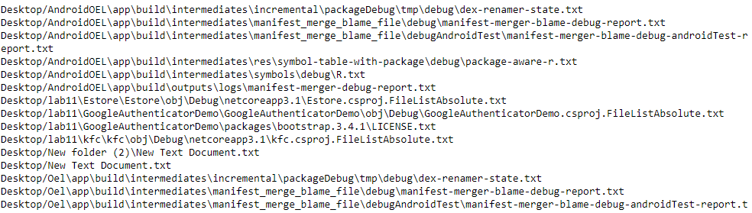

**Task 2:** Implement Fibonacci series using recursive function.

**Solution:**

def recur_fibo(n):

if n <= 1:

return nelse:

return(recur_fibo(n-1) + recur_fibo(n-2))

nterms = int(input("How many numbers do you want to write? "))

if nterms <= 0:

print("Plese enter a positive integer")else:

print("Fibonacci sequence:")

for i in range(nterms):

print(recur_fibo(i))

**Output:**

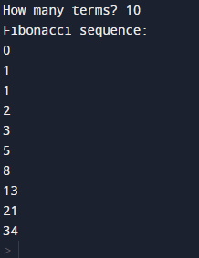

**Task 3:** Implement Undo Mechanism Using Appropriate ADT

**Solution:**

class UndoStack:

def __init__(self):

self.stack = []

def push(self, state):

self.stack.append(state)

def pop(self):

if not self.is_empty():

return self.stack.pop()

else:

return None

def is_empty(self):

return len(self.stack) == 0

undo_stack = UndoStack()

document_state = "Initial Content"

while True:

action = input("Enter an action (Type 'undo' to undo or 'exit' to exit): ")

if action == "exit":

break

elif action == "undo":

previous_state = undo_stack.pop()

if previous_state is not None:

document_state = previous_state

print(f"Undo: Document state is now '{document_state}'")

else:

print("Nothing to undo.")

else:

undo_stack.push(document_state)

document_state = action

print(f"Document state is now '{document_state}'")

**Output:**

shoaib

shoaib

shoaib

shoaib

shoaib

shoaib

shoaib

shoaib

**Task 4:** Identify ADT used in Print Job Management and implement its code as well.

**Solution:**

import queue

def print_job_management():

print_queue = queue.Queue()

while True:

print("Options:")

print("1. Submit a print job")

print("2. Print a job")

print("3. Exit")

choice = input("Enter your choice: ")

if choice == "1":

job = input("Enter the print job: ")

print_queue.put(job)

print(f"Print job '{job}' has been added to the queue.")

elif choice == "2":

if not print_queue.empty():

job = print_queue.get()

print(f"Printing: {job}")else:

print("No print jobs in the queue.")

elif choice == "3":

breakelse:

print("Invalid choice. Please choose 1, 2, or 3.")

if __name__ == "__main__":

print("Welcome to Print Job Management System")

print_job_management()

**Output:**

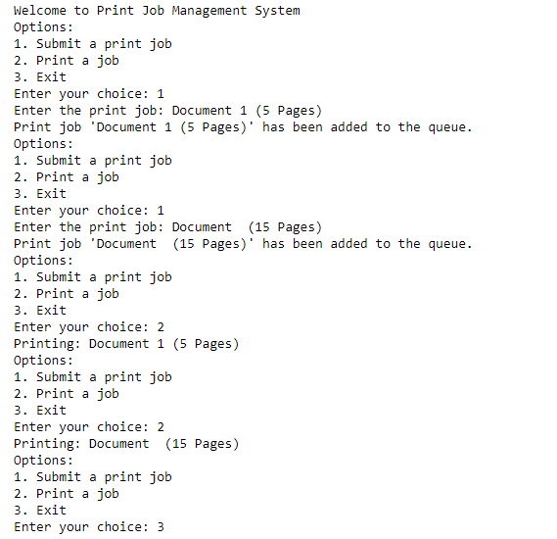

* **Task 5:** You are working on a social network analysis project and need to implement various set operations to analyze relationships between users. Your task is to implement a program that performs the following functionalities using the Set ADT:

1. Friends of Friends: Given a user, find their friends of friends (i.e., users who are friends with at least one of their friends but not directly connected to the user).
2. Mutual Friends: Given two users, find their mutual friends (i.e., users who are friends with both users).
3. Friend Suggestions: Given a user, find friend suggestions by identifying users who are friends with at least two of the user's friends but are not yet connected to the user.

**Solution:**

class SocialNetwork:

def __init__(self):

# Create a dictionary to store the relationships between users.

# The keys are user IDs, and the values are sets of their friends.

self.users = {}

def add_user(self, user_id):

# Initialize a new user with an empty set of friends.

self.users[user_id] = set()

def add_friend(self, user_id, friend_id):

# Add a friend to the user's friend set.

if user_id in self.users and friend_id in self.users:

self.users[user_id].add(friend_id)

self.users[friend_id].add(user_id)

def friends_of_friends(self, user_id):

if user_id not in self.users:

return set() # User doesn't exist, return an empty set.

user_friends = self.users[user_id]

friends_of_friends_set = set()

for friend in user_friends:

friends_of_friends_set.update(self.users[friend])

# Remove the user and their direct friends from the set.

friends_of_friends_set.discard(user_id)

friends_of_friends_set.difference_update(user_friends)

return friends_of_friends_set

def mutual_friends(self, user1, user2):

if user1 not in self.users or user2 not in self.users:

return set() # User(s) don't exist, return an empty set.

mutual_friends_set = self.users[user1].intersection(self.users[user2])

return mutual_friends_set

def friend_suggestions(self, user_id):

if user_id not in self.users:

return set() # User doesn't exist, return an empty set.

user_friends = self.users[user_id]

friend_suggestions_set = set()

for friend in user_friends:

for suggested_friend in self.users[friend]:

if suggested_friend != user_id and suggested_friend not in user_friends:

friend_suggestions_set.add(suggested_friend)

return friend_suggestions_set

if __name__ == '__main__':

social_network = SocialNetwork()

social_network.add_user(1)

social_network.add_user(2)

social_network.add_user(3)

social_network.add_user(4)

social_network.add_friend(1, 2)

social_network.add_friend(2, 3)

social_network.add_friend(3, 4)

social_network.add_friend(4, 1)

print("Friends of Friends for User 1:", social_network.friends_of_friends(1))

print("Mutual Friends between User 1 and User 3:", social_network.mutual_friends(1, 3))

print("Friend Suggestions for User 1:", social_network.friend_suggestions(1))

**Output:**

**Task 6:** Implement a gradebook analysis program using the Map ADT. The program should read a CSV file containing student names and their corresponding grades. The CSV file will have two columns: "Student Name" and "Grade". The program should analyze the grades and provide the following functionalities:

1. Calculate the average grade for all students.
2. Determine the student with the highest grade.
3. Determine the student with the lowest grade.
4. Count the number of students who received a grade above a specified threshold.

**Solution:**

import csv

reader = csv.reader(file)

next(reader)

grades = {}

for row in reader:

student_name, grade = row

if student_name in grades:

grades[student_name].append(int(grade))

else:

grades[student_name] = [int(grade)]

for student_name, student_grades in grades.items():

average_grade = sum(student_grades) / len(student_grades)

print(f'{student_name}: Average Grade = {average_grade}')

**Output:**

